**Unit 1 Lab and Association Overview**

Corey Crooks

Purdue University Global

IT331-01

Ahmed Banafa

November 16, 2022

**Part One—Lab Screenshots**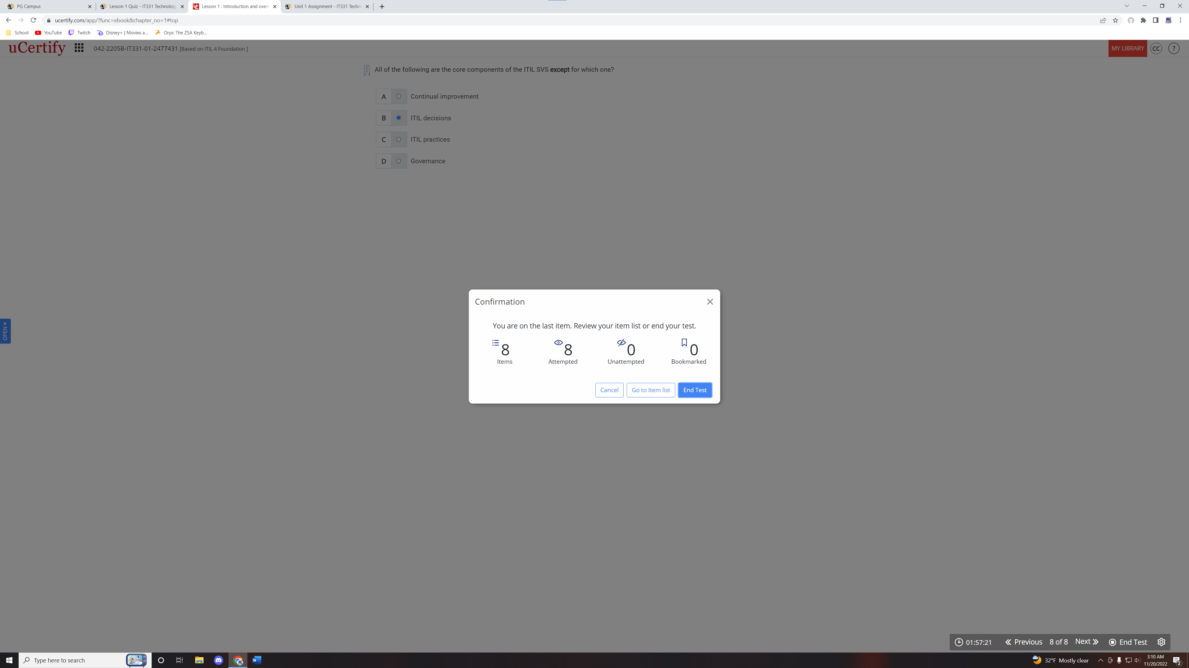

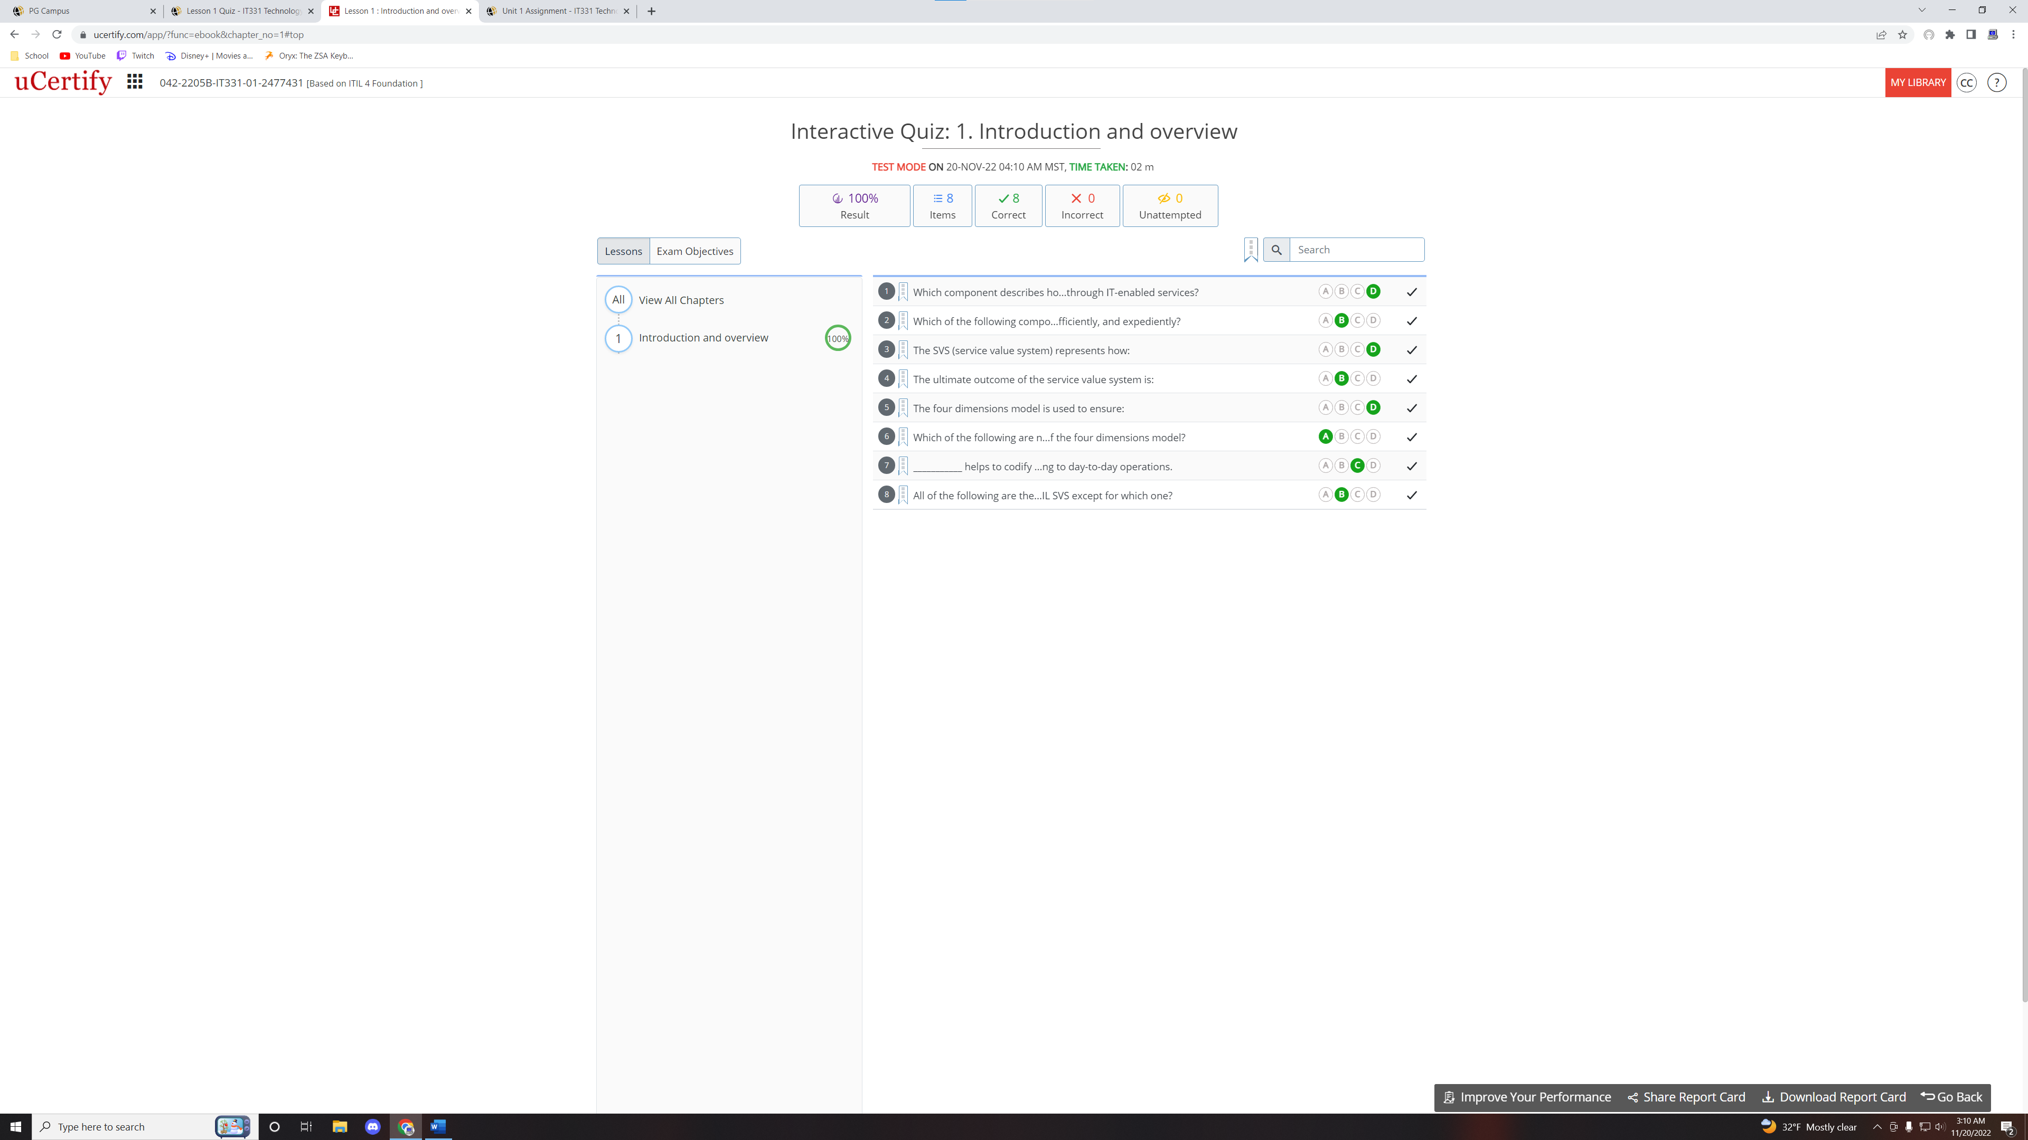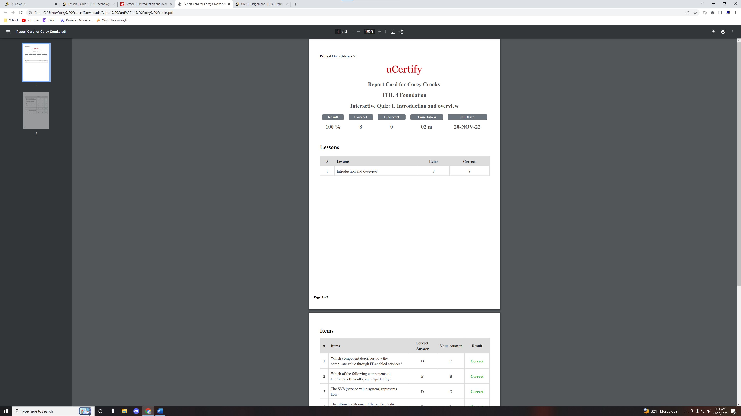

**Part 2—Writing**

The chosen industry association will be the Association of Information Technology Professionals. I have chosen this organization due to their accomplishments in relativity to my career choice and past experiences. One important factor to consider when discussing a prospective career choice would be credentials. Credentials are extremely important to demonstrate proficiency in a career path. One effective way to do this would be through professional certifications. Certifications, such as an ITIL certification, can prove to potential employers that their candidate understands material well enough to pass a regulated exam surrounding it. The ITIL certification program specifically consists of twelve different certifications that can demonstrate knowledge on specific knowledge bases including the Axelos ProPath (Axelos, 2022). The ITIL 4 Foundation certification with 2 attempts costs $489 USD; though the website that displays this information is inferring that this is a sale that has been marked down from $978 USD (1st Career.org, 2022). The Association of Information Technology hosts their own certification testing for different criteria from the ITIL 4 Foundation certifications found above. The Association of Information Technology hosts the CompTIA IT Pro certification. This demonstrates the main importance that must be considered when applying for a certification; it must be relative to a desired career path. A candidate cannot expect an employer to value a front-end specific certification for a job writing SQL programming. That being said, candidates need to make sure that their portfolio of certifications adequately demonstrates their passion and dedication towards their career. The CompTIA A+ certification provides an established knowledge in IT fundamentals, and are for candidates wishing to prove their worth in a number of full-stack development environments such as security, database design, and software programming (The Association of Information Technology, 2022). One convoluted aspect of this certification, however, is the pricing. There is a table at the bottom of the A+ certification page to demonstrate the cost for the certification. They have a Voucher for $246 USD, Basic Bundle for $359 USD, Exam Prep Bundle for $462 USD, and the eLearning Bundle available for $720. Each tier provides more benefits over the last such as an extra retake for the exam, a study-textbook, and learning labs (The Association of Information Technology, 2022). At first glance, it may seem that this certification is much cheaper than the ITIL 4 Foundation certification, but at the bottom of the website, it is mentioned that in order to achieve the CompTIA A+ certification, the student must complete two exams; and that these vouchers above may only be used for one of the two exams and must be purchased twice to complete the certification.

Certifications are not the only reason the Association of Information Technology Professionals may be relevant, however. Being an Association of Professionals, the AITP also hosts a membership. There are three ways to enroll into membership with varying perks associated to them. Firstly and most simply, one may pay a flat rate of $49 USD to gain access to an up to 20% discount on CompTIA products and certifications, access to all chapters in CompTIA books, Workforce Communities, and access to exclusive events. Secondly, one may complete the CompTIA certification process by completing and passing a certification endorsed by CompTIA. This gives you access to everything from the previous tier, with the addition of Labor Market Information, and the exception of CompTIA discounts. Finally, there is a student tier. Providing proof of enrollment at an accepted learning establishment will get you up to 50% discounts on CompTIA products, Student-Level access to CompTIA materials, Workforce Communities, and Event Access for free (CompTIA, 2022). Joining an association like this has a number of wonderful benefits over something more generic such as a profile on LinkedIn or Indeed. Since the CompTIA network is more specific, applicants can be assured that the people they meet in their CompTIA journey may have information useful to the applicant, and be able to network much more efficiently. Furthermore, the CompTIA association provides perks based on your enrollment tier such as learning materials that other free networking sites simply cannot offer. The code of conduct for the CompTIA association provides are more clear picture of the intended candidates for their positions. For example, the CompTIA association Professional Code of Ethics page details a number of rules to abide by during your tenure as an associate. These include points such as operating and sharing with integrity, strict regulations on solicitations and advertisements made by individuals in the CompTIA association, and more. This ensures that the conduct of those with the mark of association are communicating and interacting thoroughly and with precise knowledge of the topic they are speaking on.

# **References**

1st Career.org. (2022, November 11). *E-Learning Certifications* . Retrieved from 1stcareer: https://www.1stcareer.org/

Axelos. (2022). *Axelos Best Practice Certfiications*. Retrieved from axelos.com: https://www.axelos.com/certifications

CompTIA. (2022). *CompTIA IT Pro and Student Membership*. Retrieved from CompTIA.org: https://www.comptia.org/membership/it-pro

The Association of Information Technology. (2022). *CompTIA A+ Certification*. Retrieved from comptia.org: https://www.comptia.org/certifications/a